 | xx^{th} International Conference on Adaptive Intelligence and Lifelong Systems (ICAILS’25)  XXXX (XXXX), XXth to XXth May 2025  Future - Adaptive Intelligence and Lifelong Systems Journal (Future-AILS)  ISSN 2172-038 X, Volume No.XX, August 2025

Preparation of full paper for the International Conference on Adaptive Intelligence and Lifelong Systems

A. Author¹, B. Author² and C. Author¹

¹ Department Name
E.T.S.I.I., Name of University
Campus of Lagoas – Marcosende, Zipcode City (Country)
Phone/Fax number: +0034 986 812685, e-mail: A.Author@uvigo.es, C.Author@uvigo.es

² European Association for the Development of Adaptive Intelligence, and Lifelong Systems (EA4AILS)
Mailing address
Phone, fax, e-mail

Abstract. The abstract in placed in the left-hand column and starts at about 11 cm from de top of the page.

It should give concise information on the aims, the methods, the results and the conclusions of the paper. Its length should not exceed 200 words.

Key words. Please write the main key words of your text (3 to 5) separated by commas.

- Introduction

Each extended abstracts or provisional full papers will be evaluated by two or three referees, members of the ICAILS International Scientific Committee, in a peer review process, and the papers submitted will be selected on the following bases: originality, interest, quality, English level, elaboration, references and objectives/conclusions. Authors of accepted abstracts or provisional full papers will be requested to submit a definitive full paper for its inclusion in the International Conference on Renewable Energies and Power Quality USB Memory with ISBN and in the ICAILS-database. The high quality research papers presented at the ICAILS conference could be published like articles in the Future - Adaptive Intelligence and Lifelong Systems Journal (Future-AILS) with ISSN 2172-038X and the DOI. The RE&PQJ has been indexes by SCOPUS from the year 2003.

The full papers have to be sent as a pdf-file or a word file to one of the following e-mail address: icails@icails.com, secretariat@icails.com or donsion@icails.com
Explain clearly the nature of the problem, previous work, purpose and contribution of the paper, conclusions and references.
Please carefully read and follow the template to ensure a uniform quality and appearance of all contributions.

- Page Layout

Papers should not exceed six double column A4 (21x29.7cm) pages including figures, tables and diagrams. On the last page try to balance both columns.

A. Language
English (check carefully for correct grammar and spelling)

- Margins

Set the top and bottom margins to 2 cm, and the left and right margins to 1.7 cm. The spacing between the two columns should be 1.00 cm

- Justification: Full
- Headers and Footers: None
- Page Numbering: None

- Type Sizes

Manuscripts must be typed with a proportional serif typeface such as Time New Roman. The type sizes to be used for the different parts in the paper are shown in Table I.
Table I. - Type Sizes

 | SIZE | APPEARANCE
Title | 16 pt | Bold centred
Author | 12 pt | Centred
Affiliation | 10 pt | Centred
Abstract | 9 pt
Main text | 10 pt
Primary heading | 12 pt | Bold, left
Secondary headings | 10 pt | Italic, flush left
Tertiary headings | 10 pt | Italic, indented
Tables | 9 pt | Centred
Table and figure captions | 9 pt | Centred
References | 9 pt

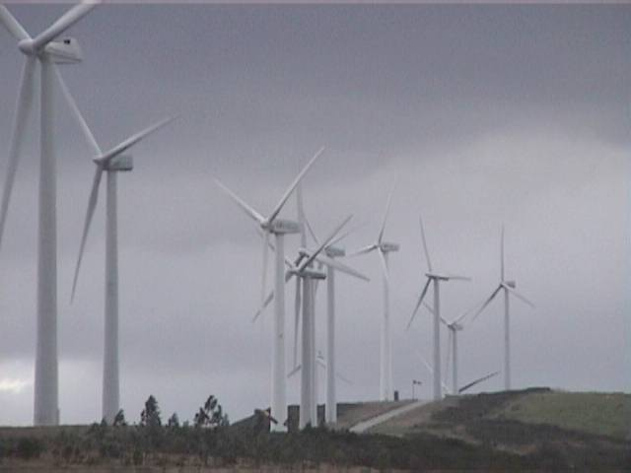
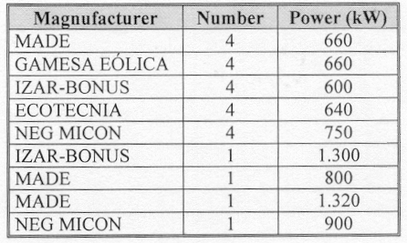

Fig. 1. General view of the Experimental Wind Park of Sotavento. Manufacturer, number and power of the generators used.

- Line Spacing

Singled spaced, with a double line space between paragraphs. Allow an extra half space above a line containing superscripts and/or below a line containing subscripts.

- Title and Headings

- Title. The title of the paper is place centred at about 5.00 cm from the top of the page and run across the upper portions of both columns.
- Primary headings. Primary headings (numbered 1., 2., 3.,...) are on the left side of the column and on separated lines.
- Secondary headings. Secondary headings (numbered A., B., C.,...) are placed flush left of the column.
- Tertiary headings. Tertiary headings (numbered 1), 2), 3),...) have a 0.6 cm indentation. The paragraph text continues indented at about 0.4 cm from the number.

- Tables and Figures

Tables and figures should be centred. Place table captions above the tables (Table I) and figure captions below the figures (Figures 1 and 2). Figures and tables may span across both columns (Fig. 1).

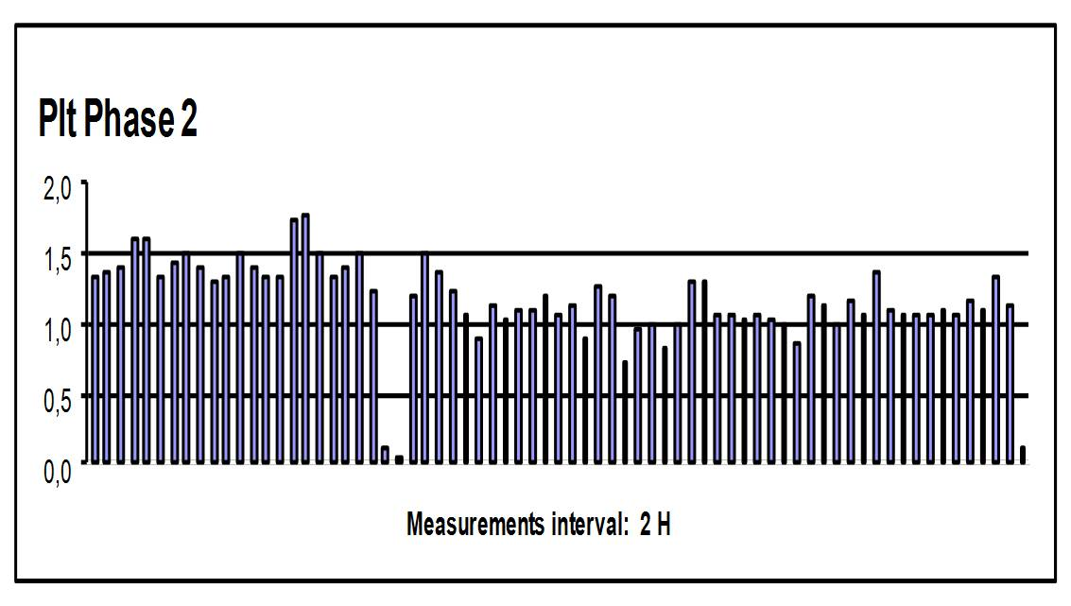
Fig.2. P_{lt} representation for phase 2

- Equations
Equations should be centred and numbered
consecutively with equations numbers in parentheses flush with the right margin, as in (1).

(1)
- References

The list of works cited should appear in the references section at the end of the paper. References must be numbered in the order cited in the manuscript and indicated in the text by a number(s) in square brackets (e.g. [1], [1]-[3], and [1],[3]).

- Further Information

Questions concerning the preparation of papers may be addressed to the International Secretariat:

European Association for the Development of Renewable Energies, Environment and Power Quality (EA4EPQ/AEDERMACP)
C/ Ramón Aller, 83
Lalin – Pontevedra. (Spain)

Phone: +34 687468629.
e-mail: secretariat@icails.com

Web site: http://www.icails.com

4. Conclusion

Should clearly indicate advantages, limitations and possible applications.

Acknowledgement

In this section financial or other support can be acknowledged. Please, don’t number neither this section, nor the following references section.

References

[1] A. Author1, Book Title, Publisher, City (2019), pp.
154-162.
[2] A. Author1, B. Author2 and C. Author3, “Title of
paper”, IEEE Transactions on Energy Conversion (2019).
Vol. 1, pp. 120-126.

