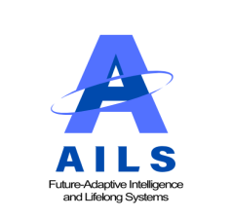
Adaptive Intelligence and Lifelong Systems
2025, Vol. 1, pp. xxx–xxx
ISSN: xxxx-xxxx
https://fupress.org/journal/AILS/index.php/journal

Article Title
Author ¹, Author ^{2*}, Author ³

¹ Title, Department, Institution, City, Country
² Title, Department, Institution, City, Country
³ Title, Department, Institution, City, Country
* Corresponding Author: xxx@xxx

Citation: X. Author, X. Author, and X. Author, “Article Title,” AILS, vol. 1, no. 1, pp. xxx–xxx, 2025, doi: xxxxxxxxxxxxx.

ARTICLE INFO |  | ABSTRACT
Received: 10 Feb 2023  Accepted: 27 Apr 2023 |  | This study explores the role of Big Data and Artificial Intelligence (AI) in enhancing sustainability in landscape design, with a focus on the impact of low-cost techniques and the mediating influence of technological literacy, as well as the moderating effect of resource availability. By analyzing the complex interactions between these elements, the research investigates how they collectively shape sustainable landscape design practices and outcomes. The study used a quantitative approach, gathering responses from 458 landscape professionals through a standardized questionnaire. Data analysis was performed using Smart PLS (Partial Least Squares), assessing measurement models, structural models, and both mediation and moderation effects. The results reveal that the integration of Big Data, AI, and cost-effective techniques significantly contributes to sustainability in landscape design. Technological literacy was identified as a key mediator, emphasizing its importance in facilitating the effective application of these technologies. Furthermore, the availability of resources was found to be a crucial moderating factor, influencing the strength of the relationships between the variables. Technological literacy was identified as a key mediator, emphasizing its importance in facilitating the effective application of these technologies.  Keywords: Implementation of Low-cost Strategies, Sustainability, Resource Availability.

INTRODUCTION

This study explores the role of Big Data and Artificial Intelligence (AI) in enhancing sustainability in landscape design, with a focus on the impact of low-cost techniques and the mediating influence of technological literacy, as well as the moderating effect of resource availability. By analyzing the complex interactions between these elements, the research investigates how they collectively shape sustainable landscape design practices and outcomes. The study used a quantitative approach, gathering responses from 458 landscape professionals through a standardized questionnaire. Data analysis was performed using Smart PLS (Partial Least Squares), assessing measurement models, structural models, and both mediation and moderation effects. The results reveal that the integration of Big Data, AI, and cost-effective techniques significantly contributes to sustainability in landscape design. Technological literacy was identified as a key mediator, emphasizing its importance in facilitating the effective application of these technologies. Furthermore, the availability of resources was found to be a crucial moderating factor, influencing the strength of the relationships between the variables. Technological literacy was identified as a key mediator, emphasizing its importance in facilitating the effective application of these technologies.

LITERATURE REVIEW

Implementation of Low-cost Strategies and Sustainability
This study explores the role of Big Data and Artificial Intelligence (AI) in enhancing sustainability in landscape design, with a focus on the impact of low-cost techniques and the mediating influence of technological literacy, as well as the moderating effect of resource availability. By analyzing the complex interactions between these elements, the research investigates how they collectively shape sustainable landscape design practices and outcomes. The study used a quantitative approach, gathering responses from 458 landscape professionals through a standardized questionnaire. Data analysis was performed using Smart PLS (Partial Least Squares), assessing measurement models, structural models, and both mediation and moderation effects. The results reveal that the integration of Big Data, AI, and cost-effective techniques significantly contributes to sustainability in landscape design. Technological literacy was identified as a key mediator, emphasizing its importance in facilitating the effective application of these technologies. Furthermore, the availability of resources was found to be a crucial moderating factor, influencing the strength of the relationships between the variables. Technological literacy was identified as a key mediator, emphasizing its importance in facilitating the effective application of these technologies.
Based on the above discussion we have developed the conceptual framework as shown in Figure 1.

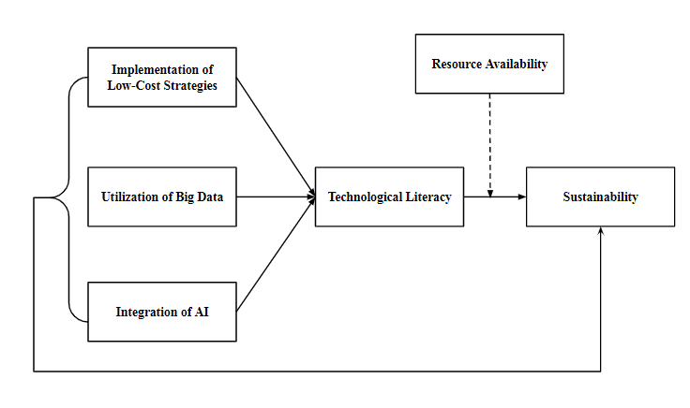
Figure 1. Conceptual Framework

METHODOLOGY

This study explores the role of Big Data and Artificial Intelligence (AI) in enhancing sustainability in landscape design, with a focus on the impact of low-cost techniques and the mediating influence of technological literacy, as well as the moderating effect of resource availability. By analyzing the complex interactions between these elements, the research investigates how they collectively shape sustainable landscape design practices and outcomes.

RESULTS

Table 1 and Figure 1 present a comprehensive assessment of construct validity and reliability for several key research topics. This study explores the role of Big Data and Artificial Intelligence (AI) in enhancing sustainability in landscape design, with a focus on the impact of low-cost techniques and the mediating influence of technological literacy, as well as the moderating effect of resource availability. By analyzing the complex interactions between these elements, the research investigates how they collectively shape sustainable landscape design practices and outcomes.

Table 6. Moderation Analysis
 | Original Sample | T values | P values
DGF -> S | 0.211 | 2.005 | 0.200
FSA-> S | 0.222 | 2.005 | 0.200
FEA -> S | 0.2324 | 2.005 | 0.200
FEWA-> S | 0.275 | 2.005 | 0.200
Note: LCS=Implementation of Low-Cost Strategies, UBD=Utilization of Big Data, IAI=Integration of AI, TL=Technological Literacy, S=Sustainability, RA=Resource Availability

DISCUSSION

This study explores the role of Big Data and Artificial Intelligence (AI) in enhancing sustainability in landscape design, with a focus on the impact of low-cost techniques and the mediating influence of technological literacy, as well as the moderating effect of resource availability. By analyzing the complex interactions between these elements, the research investigates how they collectively shape sustainable landscape design practices and outcomes.

CONCLUSION

This study explores the role of Big Data and Artificial Intelligence (AI) in enhancing sustainability in landscape design, with a focus on the impact of low-cost techniques and the mediating influence of technological literacy, as well as the moderating effect of resource availability. By analyzing the complex interactions between these elements, the research investigates how they collectively shape sustainable landscape design practices and outcomes.

LIMITATIONS

This study explores the role of Big Data and Artificial Intelligence (AI) in enhancing sustainability in landscape design, with a focus on the impact of low-cost techniques and the mediating influence of technological literacy, as well as the moderating effect of resource availability. By analyzing the complex interactions between these elements, the research investigates how they collectively shape sustainable landscape design practices and outcomes.

FUTURE DIRECTIONS

This study explores the role of Big Data and Artificial Intelligence (AI) in enhancing sustainability in landscape design, with a focus on the impact of low-cost techniques and the mediating influence of technological literacy, as well as the moderating effect of resource availability. By analyzing the complex interactions between these elements, the research investigates how they collectively shape sustainable landscape design practices and outcomes.

References

- F. S. AlHumaidan, M. A. Halabi, M. S. Rana, and M. Vinoba, “Blue hydrogen: Current status and future technologies,” Energy Convers. Manage., vol. 283, pp. 116–126, 2023.
- D. Bairrao, J. Soares, J. Almeida, J. F. Franco, and Z. Vale, “Green hydrogen and energy transition: Current state and prospects in Portugal,” Energies, vol. 16, no. 1, 2023, Art. no. 168.

